Case 5-Asia-China-Qijia-Cong-Two Tiers-Columnar-Jade-ca 2250-1900 BCE

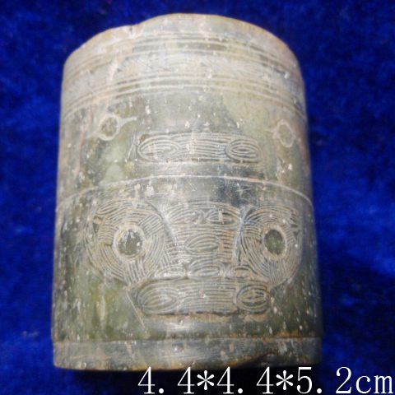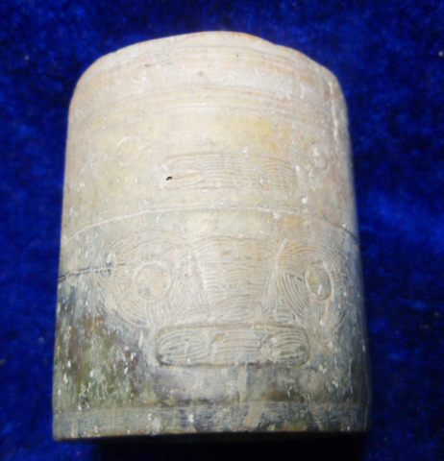

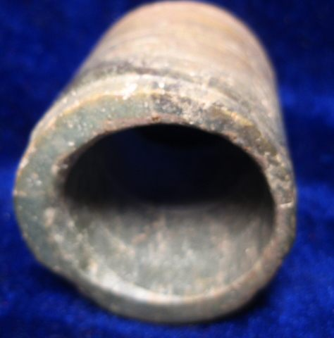

Figs. 1-3. Qijia-Cong-Columnar-Two Tiers-Jade-ca 2250-1900 BCE

Case no.: 5

Accession Number:

Formal Label: China-Qijia-Cong-Columnar-Two Tiers-Jade- ca 2250-1900 BCE

**Display Description:**

The Qijia culture (ca 2250-1900 BCE) was one of the earliest Bronze Age cultures. It was discovered in 1923 by Swedish archaeologist and geologist Johan Gunnar Andersson (1874–1960) at the Qijiaping Site in Gansu Province. Cold-hammered and cast metal utensils and mirrors have been found at Qijia sites, indicating that Qijia culture was in a transitional stage between Neolithic and Bronze Age development. As Qijia culture expanded it replaced the Majiayao Bronze Age culture sites in Eastern Gansu, Middle Gansu, and Western Gansu/Eastern Qinghai.In addition, Qijia sites expanded to Ningxia province and Inner Mongolia.

Qijia pottery featured distinctive broad, arched, strap handles and rivet-like details imitative of sheet-metal work, and suggests the existence of metal vessels at this time. Common Qijia vessel types include unpainted vessels with flat bottoms, and bodies of an orange-yellow or red-brown clay, one- and two-handled jars, and large-mouth jars. Qijia painted pottery has been found in Western Gansu and Eastern Qinghai. (after Princeton Art Museum, "http://www.w3.org/TR/xhtml1/DTD/xhtml1-transitional.dtd"><html>)

Qijia jade cong were modelled on those of the Liangzhu culture preserving the Liangzhu structure of tiered panels. However, the base of these Qijia rounded or circular cong was without the square base that characterizes all Liangzhu cong. The square base was the symbol of Earth. In contrast, Qijia cong preserve the Liangzhu structure of an anthropomorphic mask panel over an animal mask panel but this structure is accomplished within a circular cylinder, the symbol of numinous Heaven. Therefore, the philosophical thrust of a Qijia cong is to establish communication with Heaven without reference to Earth, the original basis of the Liangzhu design. It, therefore, must be a very early Qijia attempt to refashion the Liangzhu design elements into a column without the square (Earth) component on which the mask panels were originally designed to rest. Since the circle is the symbol of Heaven, then this cong with its circular base is celebrating communication with numinous Heaven as a first principle of meditation and not Earthly existence.

**LC Classification:** NK5750.2.C6

Date or Time Horizon: ca 2250-1900 BCE

Geographical Area: NW China

**Map:**

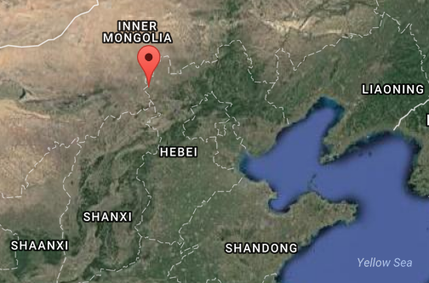 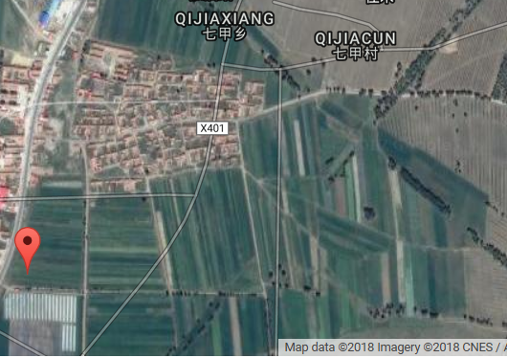

Figs. 5-6.Location of Qijia culture after Google Earth.

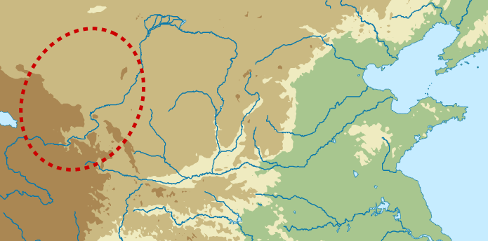

Fig. 7. Location of Qijia culture after https://upload.wikimedia.org/wikipedia/commons/a/ac/Qijia_map.svg.

**GPS coordinates:** 41° 09' 58" N, 114° 01' 59" E

Cultural Affiliation: Qijia

Medium: jade

Dimensions: Dia 4.4.cm, H 5.2 cm

Weight:

Condition: original

Provenance:

Provenance: Robin George, an Australian lawyer, joined the British army as an officer and was posted to India in the late 1800's. At the time of the Boxer rebellion 1901, he was sent with joint forces to the East.. George bought this cong after the Boxer rebellion circa 1901. He returned to England and died there ca 1940. This cong finally found its way into an auction through his descendants.

**Discussion:**

In the 1920s, a Swedish geologist uncovered the first evidence of the Qijia people in Gansu in northwestern China. Around the mid-20th and early 21st centuries, more sites were found along the upper Yellow River and various tributaries, ca suggesting that the Qijia culture existed from ca 2250-1900 BCE. Qijia people were agriculturists and raised goats, pigs, and sheep. They lived in small settlements with houses that were partly subterranean.

Within Qijia tombs, evidence of human sacrifices were found, although no one knows whom they sacrificed or why. Families were often buried in a single tomb, along with pottery, jewelry, and weapons. Scientists also discovered “bone divination lots,” which are artifacts used to predict the future.

In 1999, Chinese archaeologists stumbled upon a Qijia mystery that astounded them. They were excavating a half-underground house in a 400-dwelling village when they discovered 14 sets of human bones in three groups of three to five people each. The archaeologists had never seen so many ancient people in one Chinese house. With each group composed of one adult protecting two to four children, it looked like everyone had died suddenly in a catastrophic event. “Something enormously extraordinary must have happened to these ancients,” said archaeologist Zhao Zhinjun to the China Internet Information Center, a Chinese government portal site. “The young and strong have run for [their] life, leaving behind children and the elderly who then appeared to have hid in places they thought were safe to shelter in.”

The mystery was solved when it was discovered that a major earthquake had hit the village followed by flooding that acted as a tsunami, drowning people where they were at that instant. One interesting artifact was preserved: when a pottery bowl was found upside down on the floor, it was turned over and the earliest noodle known to exist in China was found.

**References:**

Debaine-Francfort, Corinne. 1995. *Du Neolithique a l'Age du Bronze en Chine du Nord-Ouest : la culture de Qijia et ses connexions.* Paris: Recherche sur les Civilisations.

Gu, Fang; Childs-Johnson. Elizabeth; Curnoe, Jessica. 2008. *Jades of the Qijia and related northwestern cultures of early China, ca. 2100-1600 BCE*. New York: Throckmorton Fine Art.